AP Chemistry study guide for Solutions (Chapter 11)
& Solution Stoich (Chapter 4b)

Students should be able to...
- Define: solute, solvent, solution, electrolyte, nonelectrolyte, types of solutions (combinations of matter states), suspension, colloid, Brownian movement, saturated, unsaturated, supersaturated, miscible, immiscible, Tyndall effect, hypertonic, hypotonic, isotonic
- Know the factors that affect solubility
- Calculate Molarity.
- Calculate mole fraction.
- Calculate titration data
- Explain the nonideal behavior of solutions

Sample AP problems

15. The weight of H₂SO₄ (molecular weight 98.1) in 50.0 milliliters of a 6.00-molar solution is
(A) 3.10 grams
(B) 12.0 grams
(C) 29.4 grams
(D) 294 grams
(E) 300. grams

26. How many milliliters of 11.6-molar HCl must be diluted to obtain 1.0 liter of 3.0-molar HCl?
(A) 3.9 mL
(B) 35 mL
(C) 260 mL
(D) 1,000 mL
(E) 3,900 mL
36. Appropriate laboratory procedures include which of the following?
I. Rinsing a buret with distilled water just before filling it with the titrant for the first titration
II. Lubricating glass tubing before inserting it into a stopper
III. For accurate results, waiting until warm or hot objects have reached room temperature before weighing them
(A) II only
(B) I and II only
(C) I and III only
(D) II and III only
(E) I, II, and III
43. Which of the following does NOT behave as an electrolyte when it is dissolved in water?
(A) CH₃OH
(B) K₂CO₃
(C) NH₄Br
(D) HI
(E) Sodium acetate, CH₃COONa

67. BrO₃¯ + 5 Br¯ + 6 H⁺ <===> 3 Br₂ + 3 H₂O
If 25.0 milliliters of 0.200-molar BrO₃¯ is mixed with 30.0 milliliters of 0.450-molar Br¯ solution that contains a large excess of H⁺, the amount of Br₂ formed, according to the equation above, is
(A) 5.00 x 10¯³ mole
(B) 8.10 x 10¯³ mole
(C) 1.35 x 10¯² mole
(D) 1.50 x 10¯² mole
(E) 1.62 x 10¯² mole
72. How many moles of solid Ba(NO₃)₂ should be added to 300. milliliters of 0.20-molar Fe(NO₃)₃ to increase the concentration of the NO₃¯ ion to 1.0-molar? (Assume that the volume of the solution remains constant.)
- 0.060 mole
(B) 0.12 mole
(C) 0.24 mole
(D) 0.30 mole
(E) 0.40 mole

Free Response Question (copyright College Board)

2008 part A form B question #3
A 0.150 g sample of solid lead(II) nitrate is added to 125 mL of 0.100 M sodium iodide solution. Assume no change in volume of the solution. The chemical reaction that takes place is represented by the following equation.
Pb(NO₃)₂(s) + 2 NaI(aq) → PbI₂(s) + 2 NaNO₃(aq)
(a) List an appropriate observation that provides evidence of a chemical reaction between the two compounds.
(b) Calculate the number of moles of each reactant.
(c) Identify the limiting reactant. Show calculations to support your identification.
(d) Calculate the molar concentration of NO₃–(aq) in the mixture after the reaction is complete.
(e) Circle the diagram below that best represents the results after the mixture reacts as completely as possible. Explain the reasoning used in making your choice.
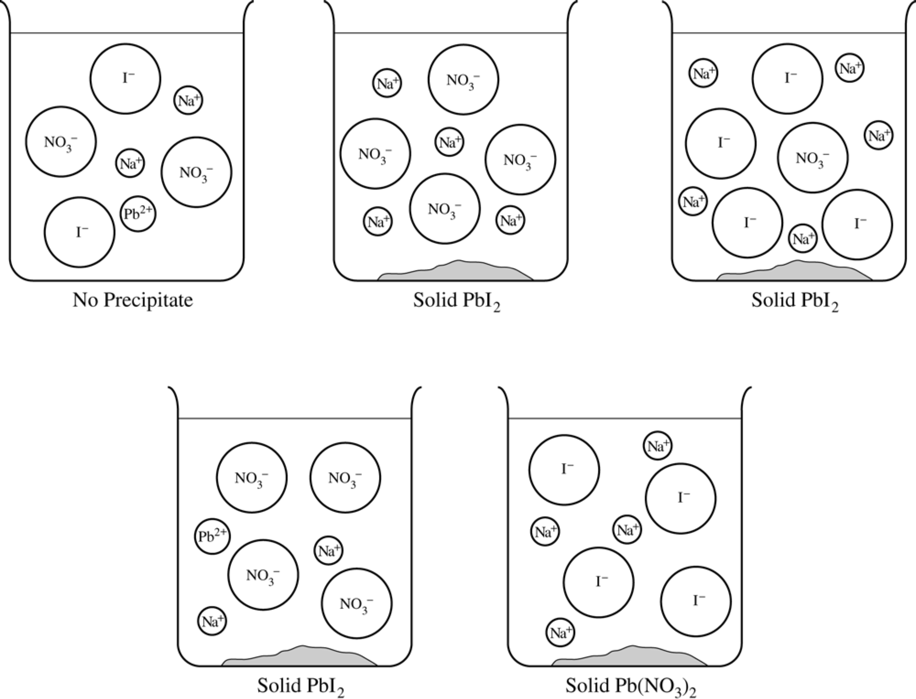
Chapter 11/4b AP Sample Problem Answers

15. C
26. C
36. D
43. A
67. B
72. A

Free response answer:

(a) formation of a yellow ppt
(b) 0.150 g Pb(NO₃)₂ × = 4.53 ×10⁻⁴ mol Pb(NO₃)₂
0.125 mL × = 0.0125 mol NaI
(c) Pb(NO₃)₂; since they react in a 1:2 ratio of Pb(NO₃)₂:NaI, 6.25 ×10⁻³ mol Pb(NO₃)₂ would be required to react with all the NaI, therefore, you would run out of the lead nitrate first
(d) the nitrate is a spectator ion, = 7.25 ×10⁻³ M

AP Chemistry – Solutions, Chapter 11/4b FAQ

Q: What are hydrophobic and hydrophilic?

A: Hydrophobic is a “fear of water”. Nonpolar substances are typically hydrophobic. They are not attracted to water. Hydrophilic on the other hand are “water lovers”. These compounds are attracted to water, and therefore are commonly ionic or polar.

Q: How do you determine is a substance will act as an electrolyte in a solution?

A: Electrolytes must have a difference in electronegativity. The bigger the difference, the better it can conduct. Usually, nonpolar substances are considered nonelectrolytes. These are commonly organic (carbon based) molecules. Polar substances are usually fair electrolytes. These substances would have lone pairs on one end of the molecule, and a shortage on the other end. Ionic substances are very good electrolytes. Ionic substances have large electronegativity differences, and may contain polyatomic ions of course.

